**TRAFFIC MANAGEMENT SYSTEM**

import cv2

import dlib

import time

import threading

import math

import helm

carCascade = cv2.CascadeClassifier('cars.xml')

bikeCascade = cv2.CascadeClassifier('motor-v4.xml')

video = cv2.VideoCapture('test.mp4')

LAG=7

WIDTH = 1280

HEIGHT = 720

OPTIMISE= 7

def estimateSpeed(location1, location2,fps):

d_pixels = math.sqrt(math.pow(location2[0] - location1[0], 2) + math.pow(location2[1] - location1[1], 2))

# ppm = location2[2] / carWidht

ppm = 8.8

d_meters = d_pixels / ppm

if fps == 0.0:

fps = 18

speed = d_meters * fps * 3.6

return speed

def trackMultipleObjects():

rectangleColor = (0, 255, 0)

frameCounter = 0

currentCarID = 0

currentBikeID=0

fps = 0

carTracker = {}

bikeTracker = {}

bikeNumbers = {}

carNumbers = {}

bikeLocation1 = {}

carLocation1 = {}

bikeLocation2 = {}

carLocation2 = {}

speed = [None] * 1000

go =[False for i in range(1000)]

identity = [0 for i in range(1000)]

snaps = [False for i in range(1000)]

types = ["cars" for i in range(1000)]

Helmets = ["No Helmet Detected" for i in range(1000)]

out = cv2.VideoWriter('outpy.avi',cv2.VideoWriter_fourcc('M','J','P','G'), 10, (WIDTH,HEIGHT))

while True:

start_time = time.time()

rc, image = video.read()

if type(image) == type(None):

break

image = cv2.resize(image, (WIDTH, HEIGHT))

resultImage = image.copy()

frameCounter = frameCounter + 1

carIDtoDelete = []

for carID in carTracker.keys():

trackingQuality = carTracker[carID].update(image)

if trackingQuality < 7:

carIDtoDelete.append(carID)

for carID in carIDtoDelete:

print ('Removing carID ' + str(carID) + ' from list of trackers.')

print ('Removing carID ' + str(carID) + ' previous location.')

print ('Removing carID ' + str(carID) + ' current location.')

carTracker.pop(carID, None)

carLocation1.pop(carID, None)

carLocation2.pop(carID, None)

if not (frameCounter % 10):

gray = cv2.cvtColor(image, cv2.COLOR_BGR2GRAY)

cars = carCascade.detectMultiScale(gray, 1.1, 13, 18, (24, 24))

bikes = bikeCascade.detectMultiScale(gray, 1.1 , 13, 18, (24,24))

for (_x, _y, _w, _h) in cars:

x = int(_x)

y = int(_y)

w = int(_w)

h = int(_h)

roi = image[y:y+h,x:x+w]

x_bar = x + 0.5 * w

y_bar = y + 0.5 * h

matchCarID = None

for carID in carTracker.keys():

trackedPosition = carTracker[carID].get_position()

t_x = int(trackedPosition.left())

t_y = int(trackedPosition.top())

t_w = int(trackedPosition.width())

t_h = int(trackedPosition.height())

t_x_bar = t_x + 0.5 * t_w

t_y_bar = t_y + 0.5 * t_h

if ((t_x <= x_bar <= (t_x + t_w)) and (t_y <= y_bar <= (t_y + t_h)) and (x <= t_x_bar <= (x + w)) and (y <= t_y_bar <= (y + h))):

matchCarID = carID

if matchCarID is None:

print ('Creating new tracker ' + str(currentCarID))

tracker = dlib.correlation_tracker()

tracker.start_track(image, dlib.rectangle(x, y, x + w, y + h))

carTracker[currentCarID] = tracker

carLocation1[currentCarID] = [x, y, w, h]

currentCarID = currentCarID + 1

for (_x, _y, _w, _h) in bikes:

x = int(_x)

y = int(_y)

w = int(_w)

h = int(_h)

x_bar = x + 0.5 * w

y_bar = y + 0.5 * h

matchCarID = None

for carID in carTracker.keys():

trackedPosition = carTracker[carID].get_position()

t_x = int(trackedPosition.left())

t_y = int(trackedPosition.top())

t_w = int(trackedPosition.width())

t_h = int(trackedPosition.height())

t_x_bar = t_x + 0.5 * t_w

t_y_bar = t_y + 0.5 * t_h

if ((t_x <= x_bar <= (t_x + t_w)) and (t_y <= y_bar <= (t_y + t_h)) and (x <= t_x_bar <= (x + w)) and (y <= t_y_bar <= (y + h))):

matchCarID = carID

if matchCarID is None:

print ('Creating new tracker ' + str(currentCarID))

tracker = dlib.correlation_tracker()

tracker.start_track(image, dlib.rectangle(x, y, x + w, y + h))

carTracker[currentCarID] = tracker

carLocation1[currentCarID] = [x, y, w, h]

types[currentCarID]= "bikes"

currentCarID = currentCarID + 1

for carID in carTracker.keys():

trackedPosition = carTracker[carID].get_position()

t_x = int(trackedPosition.left())

t_y = int(trackedPosition.top())

t_w = int(trackedPosition.width())

t_h = int(trackedPosition.height())

cv2.rectangle(resultImage, (t_x, t_y), (t_x + t_w, t_y + t_h), rectangleColor, 4)

carLocation2[carID] = [t_x, t_y, t_w, t_h]

end_time = time.time()

fps=0.0

for i in carLocation1.keys():

if frameCounter % 1 == 0:

[x1, y1, w1, h1] = carLocation1[i]

[x2, y2, w2, h2] = carLocation2[i]

carLocation1[i] = [x2, y2, w2, h2]

if [x1, y1, w1, h1] != [x2, y2, w2, h2]:

result = False

roi = resultImage[y1:y1+h1,x1:x1+w1]

if types[i]=="bikes" and Helmets[i] == "No Helmet Detected" and identity[i]< OPTIMISE:

result = helm.detect(roi)

if result==True:

Helmets[i]= "Helmet Detected"

if 7==7:

if not (end_time == start_time):

fps = 1.0/(end_time - start_time)

speed[i] = estimateSpeed([x1, y1, w1, h1], [x2, y2, w2, h2],fps)

if int(speed[i])>40:

speed[i]= speed[i]%40

if go[i] == True and int(speed[i])<10:

speed[i]=speed[i]+15

if int(speed[i])==0:

continue

if int(speed[i])>30:

go[i]=True

cv2.putText(resultImage, "OverSpeeding ALERT", (int(x1 + w1/2), int(y1-5)),cv2.FONT_HERSHEY_SIMPLEX, 0.75, (0, 0, 255), 2)

elif speed[i] != None and y1 >= 180 and speed[i]!=0:

ans= str(int(speed[i])) + " km/hr "

if types[i]=="bikes":

ans= ans+ Helmets[i]

cv2.putText(resultImage, ans, (int(x1 + w1/2), int(y1-5)),cv2.FONT_HERSHEY_SIMPLEX, 0.75, (0, 255, 0), 2)

identity[i]+=1

cv2.imshow('result', resultImage)

if cv2.waitKey(33) == 27:

break

cv2.destroyAllWindows()

if _name_ == '_main_':

trackMultipleObjects()

The main file to run the project…

from time import sleep

import cv2 as cv

import argparse

import sys

import numpy as np

import os.path

from glob import glob

#from PIL import image

frame_count = 0 # used in mainloop where we're extracting images., and then to drawPred( called by post process)

frame_count_out=0 # used in post process loop, to get the no of specified class value.

# Initialize the parameters

confThreshold = 0.5 #Confidence threshold

nmsThreshold = 0.4 #Non-maximum suppression threshold

inpWidth = 416 #Width of network's input image

inpHeight = 416 #Height of network's input image

# Load names of classes

classesFile = "obj.names";

classes = None

with open(classesFile, 'rt') as f:

classes = f.read().rstrip('\n').split('\n')

# Give the configuration and weight files for the model and load the network using them.

modelConfiguration = "yolov3-obj.cfg";

modelWeights = "yolov3-obj_2400.weights";

net = cv.dnn.readNetFromDarknet(modelConfiguration, modelWeights)

net.setPreferableBackend(cv.dnn.DNN_BACKEND_OPENCV)

net.setPreferableTarget(cv.dnn.DNN_TARGET_CPU)

# Get the names of the output layers

def getOutputsNames(net):

# Get the names of all the layers in the network

layersNames = net.getLayerNames()

# Get the names of the output layers, i.e. the layers with unconnected outputs

return [layersNames[i-1] for i in net.getUnconnectedOutLayers()]

# Draw the predicted bounding box

def drawPred(classId, conf, left, top, right, bottom, frame):

global frame_count

# Draw a bounding box.

#cv.rectangle(frame, (left, top), (right, bottom), (255, 178, 50), 3)

label = '%.2f' % conf

# Get the label for the class name and its confidence

if classes:

assert(classId < len(classes))

label = '%s:%s' % (classes[classId], label)

#Display the label at the top of the bounding box

labelSize, baseLine = cv.getTextSize(label, cv.FONT_HERSHEY_SIMPLEX, 0.5, 1)

top = max(top, labelSize[1])

#print(label) #testing

#print(labelSize) #testing

#print(baseLine) #testing

label_name,label_conf = label.split(':') #spliting into class & confidance. will compare it with person.

if label_name == 'Helmet':

#will try to print of label have people.. or can put a counter to find the no of people occurance.

#will try if it satisfy the condition otherwise, we won't print the boxes or leave it.

#cv.rectangle(frame, (left, top - round(1.5*labelSize[1])), (left + round(1.5*labelSize[0]), top + baseLine), (255, 255, 255), cv.FILLED)

#cv.putText(frame, label, (left, top), cv.FONT_HERSHEY_SIMPLEX, 0.75, (0,0,0), 1)

frame_count+=1

#print(frame_count)

if(frame_count> 0):

return frame_count

# Remove the bounding boxes with low confidence using non-maxima suppression

def postprocess(frame, outs):

frameHeight = frame.shape[0]

frameWidth = frame.shape[1]

frame_count_out=0

classIds = []

confidences = []

boxes = []

# Scan through all the bounding boxes output from the network and keep only the

# ones with high confidence scores. Assign the box's class label as the class with the highest score.

classIds = [] #have to fins which class have hieghest confidence........=====>>><<<<=======

confidences = []

boxes = []

for out in outs:

for detection in out:

scores = detection[5:]

classId = np.argmax(scores)

confidence = scores[classId]

if confidence > confThreshold:

center_x = int(detection[0] * frameWidth)

center_y = int(detection[1] * frameHeight)

width = int(detection[2] * frameWidth)

height = int(detection[3] * frameHeight)

left = int(center_x - width / 2)

top = int(center_y - height / 2)

classIds.append(classId)

#print(classIds)

confidences.append(float(confidence))

boxes.append([left, top, width, height])

# Perform non maximum suppression to eliminate redundant overlapping boxes with

# lower confidences.

indices = cv.dnn.NMSBoxes(boxes, confidences, confThreshold, nmsThreshold)

count_person=0 # for counting the classes in this loop.

for i in indices:

i = i[0]

box = boxes[i]

left = box[0]

top = box[1]

width = box[2]

height = box[3]

#this function in loop is calling drawPred so, try pushing one test counter in parameter , so it can calculate it.

frame_count_out = drawPred(classIds[i], confidences[i], left, top, left + width, top + height, frame)

#increase test counter till the loop end then print...

#checking class, if it is a person or not

my_class='Helmet' #======================================== mycode .....

unknown_class = classes[classId]

if my_class == unknown_class:

count_person += 1

#if(frame_count_out > 0):

#print(frame_count_out)

if count_person >= 1:

path = 'test_out/'

# frame_name=os.path.basename(fn) # trimm the path and give file name.

#cv.imwrite(str(path)+frame_name, frame) # writing to folder.

#print(type(frame))

#cv.imshow('img',frame)

#cv.waitKey(800)

return 1

else:

return 0

#cv.imwrite(frame_name, frame)

# Process inputs

winName = 'Deep learning object detection in OpenCV'

cv.namedWindow(winName, cv.WINDOW_NORMAL)

def detect(frame):

#frame = cv.imread(fn)

frame_count =0

# Create a 4D blob from a frame.

blob = cv.dnn.blobFromImage(frame, 1/255, (inpWidth, inpHeight), [0,0,0], 1, crop=False)

# Sets the input to the network

net.setInput(blob)

# Runs the forward pass to get output of the output layers

outs = net.forward(getOutputsNames(net))

# Remove the bounding boxes with low confidence

# Put efficiency information. The function getPerfProfile returns the overall time for inference(t) and the timings for each of the layers(in layersTimes)

t, _ = net.getPerfProfile()

#print(t)

label = 'Inference time: %.2f ms' % (t * 1000.0 / cv.getTickFrequency())

#print(label)

#cv.putText(frame, label, (0, 15), cv.FONT_HERSHEY_SIMPLEX, 0.5, (0, 0, 255))

#print(label)

k=postprocess(frame, outs)

if k:

return 1

else:

        return 0

**OUTPUT**

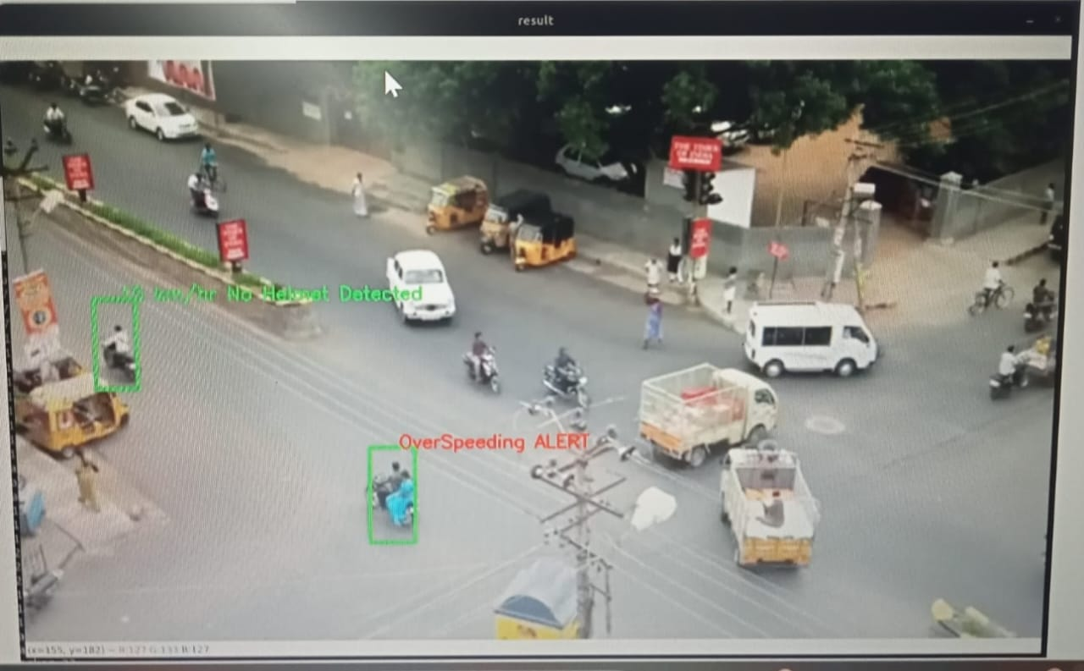

**COMMUNICATION BETWEEN IOT HARDWARE AND THE SOFTWARE**

IoT can also use artificial intelligence and machine learning to aid in making data collection processes easier and more dynamic. An IoT system collects data from sensors installed in IoT devices and transfers that data through an IoT gateway for it to be analyzed by an application or back-end system.

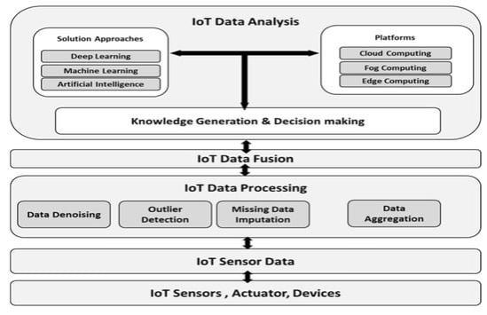

On the Internet of Things (IoT), data from multiple sensors is typically managed using a combination of hardware, software, and networking solutions.

First, the data from the sensors is collected and processed by hardware devices, such as gateway devices or edge computers. These devices are typically located at the point where the sensors are deployed and are responsible for collecting and aggregating the data from the sensors. The hardware devices may also perform some initial processing and filtering of the data to remove any irrelevant or incorrect information.

Next, the data from the hardware devices is transmitted to a central server or cloud platform, where it is stored and managed. This typically involves using a network, such as a cellular or Wi-Fi network, to transmit the data from the hardware devices to the central server. The data is then stored in a database or data lake, where it can be accessed and analyzed by various applications and tools.

Finally, the data from the sensors is typically accessed and analyzed using a combination of software tools and applications. These tools and applications may include dashboards, analytics software, and machine learning algorithms, which can help to visualize, analyze, and make sense of the data.

There are many different software tools that can be used to analyze data from sensors in the Internet of Things (IoT). Some examples of these tools include:

Data visualization tools, such as dashboards and charts, which can help to visualize and understand the data in a graphical format.

Analytics software, such as business intelligence and predictive analytics tools, which can help to analyze the data and identify trends, patterns, and anomalies.

Machine learning algorithms, which can be used to build predictive models and make predictions based on the data.

Stream processing and real-time analytics tools, which can help to process and analyze high volumes of data in real time.

Data management and storage solutions, such as databases and data lakes, which can help to store and manage the data from the sensors.

The specific tools that are used will depend on the type and volume of data, as well as the specific goals and objectives of the analysis.

Overall, managing data from multiple sensors in the IoT involves a combination of hardware, software, and networking solutions, which work together to collect, transmit, store, and analyze the data from the sensors.